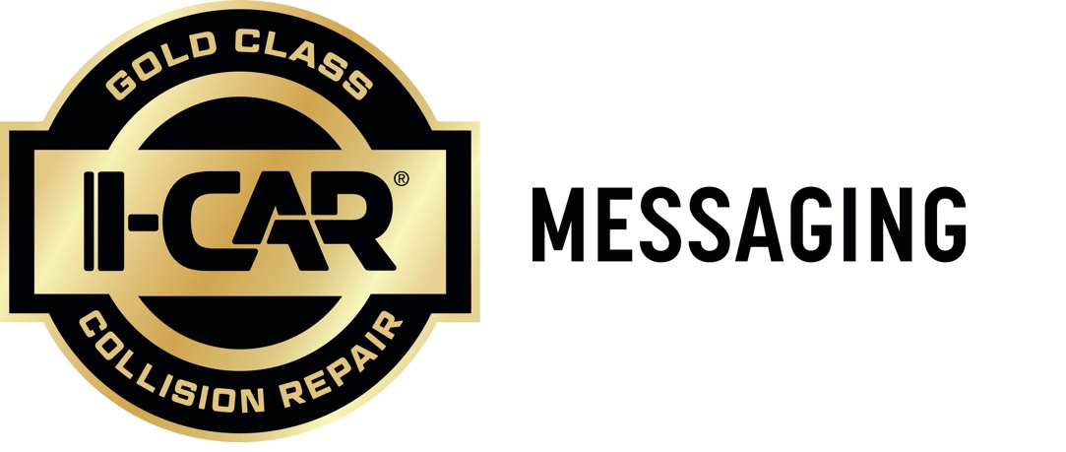

Example 1:
Our Shop and Our Standards Are Gold Class®.
As an I-CAR® Gold Class repair shop, you can be confident your vehicle is getting trusted care you can count on. It means our technicians are trained on the latest industry procedures and technologies to ensure your repairs meet the highest quality and safety standards.
Example 2:
Gold Class® Status means Gold Class Service.
Our status as an I-CAR® Gold Class shop means we’ve gone above and beyond to complete and maintain collision repair training requirements, so you can be sure your vehicle repairs are performed to the highest industry standards.
Example 3:
We’re proud to have a Gold Class® designation.
This means we’ve gone above and beyond to complete and maintain collision repair training requirements.
Example 4:
Our I-CAR® Gold Class® status means we meet the industry’s highest standards in collision repair.
We’re trained and committed to repairing your vehicle the right way.
Example 5:
We’re proud to be a Gold Class® shop you can count on.

